**2018-19**

**Liberty Elementary Schedule**

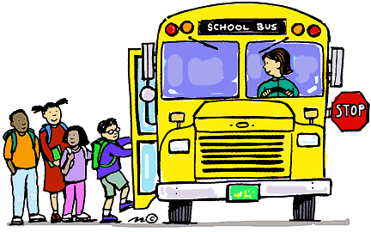

* **Liberty front doors will open at 8:35am**
* **Breakfast served in the cafeteria – 8:35-8:45am**
* **8:45am students head to class Instruction starts at** **8:50am**
* **ALL students arriving after 8:50am MUST report to the office.**
* **Students released at** **3:25 (except on Wednesdays-2:25pm)**
* **Bus riders drop off and pick up area on Liberty Street.**
* **Walkers/Car Riders-enter & exit Liberty front doors on 24th Street**

Kindergarten 8:50-3:25 3 rd Grade 8:50-3:25  
AM recess 10:25-10:35 AM recess 10:25-10:35

Lunch 11:10-11:30 Lunch 11:55-12:15   
Recess 11:30-11:50 Recess 12:15-12:35

PM Recess 2:00-2:10 PM Recess 2:00-2:10

NO PM Recess on Wednesdays NO PM Recess on Wednesdays

1 st Grade 8:50-3:25 4th Grade 8:50-3:25  
AM recess 10:25-10:35 AM recess 10:25-10:35

Recess 11:10-11:30 Lunch 11:55-12:15   
Lunch 11:30-11:50 Recess 12:15-12:35

PM Recess 2:00-2:10 PM Recess 2:00-2:10

NO PM Recess on Wednesdays NO PM Recess on Wednesdays

2 nd Grade 8:50-3:25 5 th Grade 8:50-3:25  
AM recess 10:25-10:35 AM recess 10:25-10:35

Recess 11:10-11:30 Recess 11:55-12:15   
Lunch 11:30-11:50 Lunch 12:15-12:35

PM Recess 2:00-2:10 PM Recess 2:00-2:10

NO PM Recess on Wednesdays NO PM Recess on Wednesdays

***Early Dismissal*** *EVERY Wednesday at* ***2:25pm***

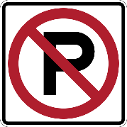The yellow zone in front of the school is a “no parking” zone from 8am-4pm every school day. This is to allow for emergency vehicles and busses access to the front of the school. In the morning when dropping off your child, however, please pull over to the yellow curb briefly to allow your child to safely exit your vehicle. We understand there is a lot of traffic in the morning, but for the safety of all students, please don’t stop in the middle of the street to let your child out. Thank you for your help!